Title: ML1819 Research Assignment 1
Team ID: 43
Task ID: 103
Paper Title: Analyzing forecasting models based on the different granularity of time series data.

Student Details:
Student Name | Student ID
Lal Singh Dhaila | 18304211
Roman Shaikh | 18300989
Aman Ray | 18301719

Contributions:

Student Name | Contribution
Lal Singh Dhaila | - Selection of appropriate time series dataset  - Seasonality Removal Using three different methods namely log, moving average and difference  - Custom code to identify minimum AIC value
Roman Shaikh | - Trend analysis  - Testing of Stationarity using Augmented Dicky test  - Calculation of MSE and MASE error
Aman Ray | - Data Cleaning  - Comparison of ARIMA and SARIMA model  - Plotting diagnostics ARIMA Model
Word Count: 992 (Excluding abstract, titles, index terms, labels and References )
Source Code: https://github.com/aman-ray-tcd/ML1819--task-103--team-43
Source Code Activity Link: https://github.com/aman-ray-tcd/ML1819--task-103--team-43/graphs/contributors

Analyzing forecasting models based on the different granularity of time series data.

Lal Singh Dhalia  Trinity College Dublin  dhailal@tcd.ie | Roman Shaikh  Trinity College Dublin  shaikhr@tcd.ie | Aman Ray  Trinity College Dublin  raya@tcd.ie

Abstract—Machine learning forecasting models are very popular for predicting future values based on observed values. These are based on datasets which have a time series distribution. In this paper, we study the effects of data granularity on predictions of forecasting models (ARIMA and SARIMAX) and try to find the effectiveness based on training the models on different granularity levels.

Index Terms—Forecasting model, data granularity, time series, ARIMA, SARIMA

Introduction
Forecasting models are used in machine learning in different areas like weather forecasting and predicting stock prices. Often these are based on historical time series data. Generally, the granularity of data is not considered while training the model for forecasting. In this paper, we try to study the effects of granularity of data on machine learning forecasting models.

We will analyze a dataset for passengers commuting through an airport throughout the year. We train our model using ARIMA for forecasting passengers commuting in a quarter through an airport. For this firstly we train the model on monthly data and predict the number of passengers commuting in a quarter. Secondly, we train the model on quarterly data and predict the number of passengers commuting in the same quarter. We compare the results using standard RMSE.

With this approach we try to analyze the accuracy of forecasted predictions based on different granularity levels. For further confirming our results we will apply the same technique using a different forecasting model called SARIMAX.

RELATED WORKS
Ming-Chien [6] in his research paper wrote about the use of multiple granularity levels, which discusses more time-delayed relationship. Another researcher J Beel [2] in his research paper discussed use of the small-time frame to check the effectiveness of the algorithm. In this paper we try to analyze the effectiveness of the different granularity level on forecasting models.

Data Preparation
To do the forecasting analysis its necessary that data should be in time series format, which includes conversion of data into DateTimeIndex. Once the data is converted into time series its necessary to handle the outliers and missing values, which is being handled by removing the row.

STAITIONARITY AND MODEL BUILDING
We are using ARIMA and SARIMAX algorithms [1,3] to forecast the number of customers that are going to commute through San Francisco airport in future. Below are the steps that have been taken care before forecasting:
- Trend: From Figure 1 an upward trend
- Seasonality: In Figure 1 peaks can be seen easily which signifies that there is seasonality in the data. Before proceeding further and forecasting we must remove the seasonality.
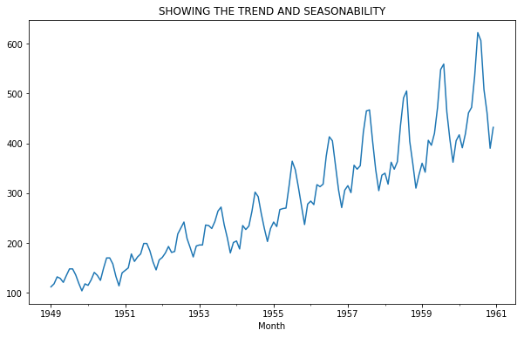
Figure 1: Showing the trend and seasonality in the data.

Removal of the stationarity and seasonality is the crucial part of any time series related problem. This helps to ease in making prediction. To achieve the stationarity; moving average, central moving average or weighted moving average can be used. For this, we have used data moving average concept followed by log transformation.
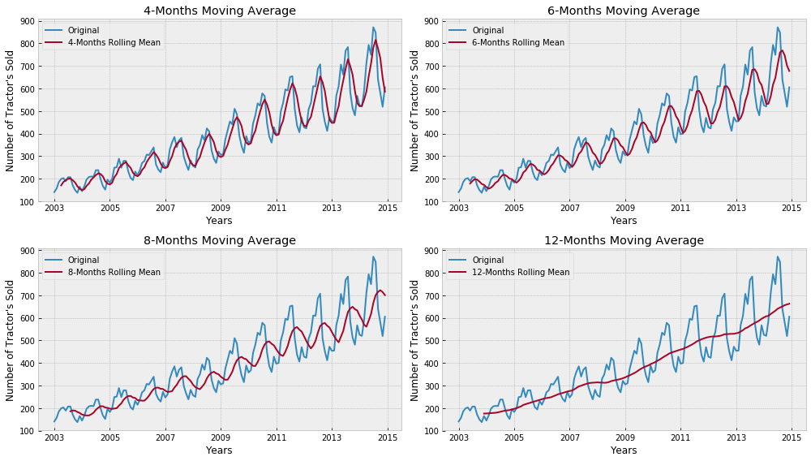
Figure 2: Making data stationary using moving average

To further test the stationarity, we performed the Augmented Dicky test. In this, we compare the calculated p-value against the p-value of 0.05. Once the stationarity is achieved, the p and q values are calculated using autocorrelation function (ACF) and partial autocorrelation function (PACF). We define the value in the form of (AR, I, MA) where AR is an auto regressive parameters, MA is moving average parameters and I represent the part of the model. The value of I is then calculated using the number of differences that have been done to achieve the stationarity. Based on the (AR, I,MA) values the AIC (Akaike Information Criterion) and BIC (Bayesian Information Criterion) are selected which tells us to what extent the model is reliable. Lesser the value of the AIC, more reliable will be the model.

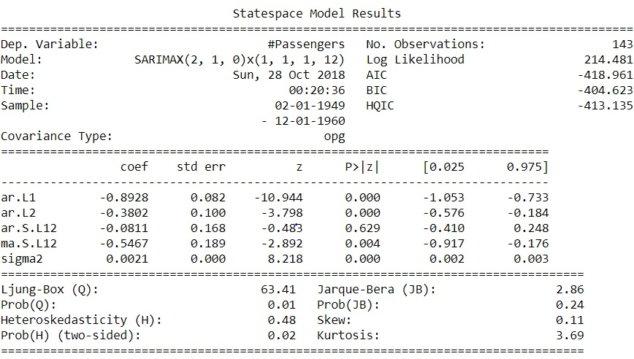
Figure 3: showing the complete State space model for SARIMAX.

FORECASTING/PREDICTION
Here we are forecasting the data for each quarter of the year. The prediction is done based on the training data. The robustness of the model is tested by plotting the below charts:

- Standardized residual
- Histogram plus estimated density
- Normal Q-Q plot
- Correlogram

Below Figure 4 shows the plot diagnostics for ARIMA model.

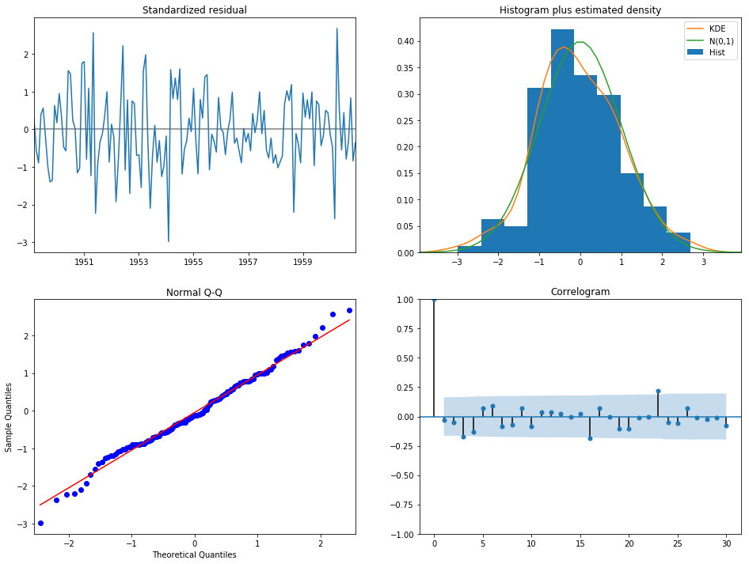
Figure 4: ARIMA model plot diagnostics
We need to ensure that the residuals of our model are uncorrelated and normally distributed with zero mean. If they are not, then it signifies that the model can be further improved, and the process is repeated with the residuals. The
KDE plot of the residuals on the top right is almost similar to the normal distribution. The qq plot on the bottom left (Figure 4) shows that the ordered distribution of residuals (blue dots) follows the linear trend of the samples taken from a standard normal distribution with N(0, 1). Again, this is a strong indication that the residuals are normally distributed. The residuals over time (top left plot Figure 4) do not display any obvious seasonality and appear to be white noise. This is confirmed by the autocorrelation (i.e. correlogram) plot on the bottom right, which shows that the time series residuals have low correlation with lagged versions of itself.

RESULT
We checked the reliability of this model (both ARIMA and SARIMA) by dividing the data into test and train. We compare the result predicted by the model with the quarterly test data. Knowing the prediction of passengers commuting from the airport in future quarters, the values forecasted by the models were then plotted with actual predictions to check the reliability of the model. Figure 5 and Figure 6 shows the prediction for future quarterly commutes using SARIMA and ARIMA models respectively.

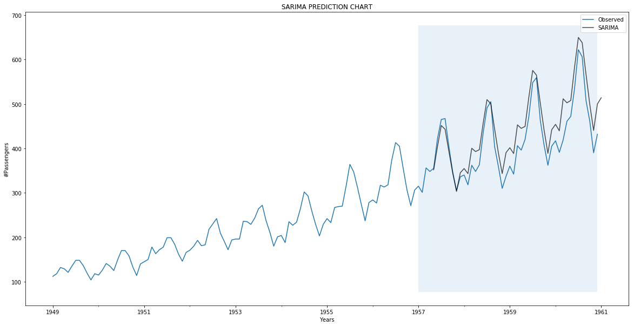
Figure 5: SARIMA future prediction after 1957.

In above Figure 5 blue line is showing the actual observation and black line is showing the predicted value using SARIMA.

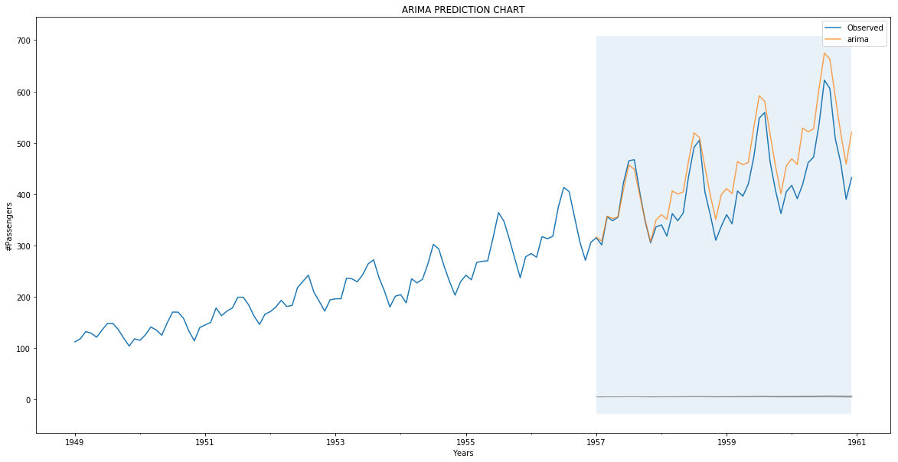
Figure 6: ARIMA future prediction after 1957.

Table 1: MSE and MASE value for SARIMA and ARIMA (Monthly)
Algorithm | MSE | MASE
SARIMA | 0.0076 | 0.076
ARIMA | 0.0113 | 0.0904

To check how well the model worked in forecasting the passenger commute volume for the future months, we have first predicted the number of passenger commute in a time interval with known data. To show the accuracy of the two models over time series data the Mean Square Error (MSE) and Mean Absolute Scaled Error (MASE) is calculated as shown in Table 1.

Algorithm | MSE | MASE
SARIMA | 50.9616 | 7.1359
ARIMA | 50.8746 | 7.1299
Table 2: MSE and MASE value for SARIMA and ARIMA (Quarterly)

If the prediction is done considering quarterly intervals, we observed that the forecasted value is too low as shown in Figure 7. Moreover, calculation of MSE and MASE shows high value in case of quarterly calculation. Since we tested these models on two different algorithms we can safely conclude that prediction on a low granularity level (monthly) produces a better result over a high granularity data (quarterly). This is independent of the algorithm’s implementation. Also, the error rate is comparatively low while using low granularity data.

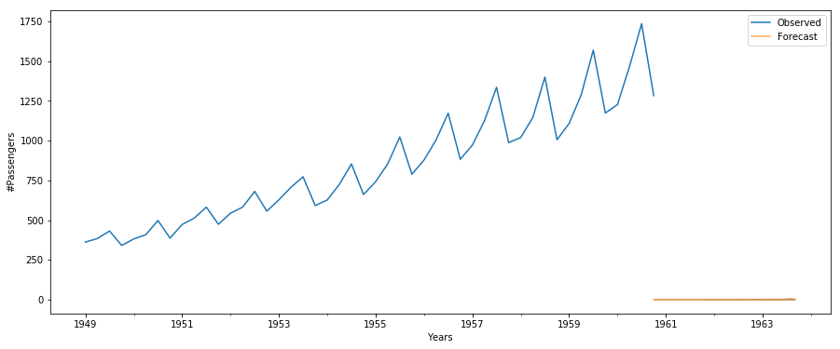
Figure 6: ARIMA and SARIMA showing same trend (quarterly)

LIMITATIONS & OUTLOOK
Missing data is still a big challenge in this filed as replacing with mean average doesn’t land on good forecasting. Moreover, if the data is analyzed based on more granularity level i.e. hourly, weekly would give us more a more robust forecasting model. Although SARIMA model is more effective but finding the perfect pdq value is still a challenge.

REFERENCES

- Peter J. Brockwell and Richard A. Davis “Introduction to Time Series and Forecasting,”

- Joeran Beel “It's Time to Consider "Time" when Evaluating Recommender-System Algorithms [Proposal]”

- Chris Chatfield, “The Analysis of Time Series: An Introduction, Sixth Edition,” Ref. for SARIMA

- Roopam Upadhyay (2015) Forecasting & Time Series Analysis – Manufacturing Case Study Example (Blog Post).Retrieved from https://goo.gl/essiej

- Robert Nau (2018) ARIMA models for time series forecasting(Blog Post). Retrived from https://people.duke.edu/~rnau/411home.htm

- Mehmet Sayal and Ming-Chien Shan “Time series data analysis in multiple granularity levels”. https://www.inderscienceonline.com/doi/pdf/10.1504/IJGCRSIS.2009.026725

